Evaluation of Model Predictions
To evaluate the model’s predictions against observed depth occupancy we summarized depth occupancy at various time scales and corresponding predictions across each of the selected features. For seasonal effects, we compared the monthly proportion of occurrences in each depth bin in the validation set to the monthly mean probability of occupancy in each depth bin as predicted by the model. To evaluate diel variation, we converted our sin_sun and cos_sun features back into radians, which was then binned, and computed the actual proportions of occurrences at depths lower than 25 m across month and 24-hour cycle for both the training and validation sets. We then compared these observations to the monthly mean probability of depth occupancy deeper than 25 m across the day as predicted by the model using the validation set. Finally, for each of our selected environmental features (mixed layer thickness, salinity, and nitrate) we binned each feature and then, per month, compared the observed proportion of occurrences below 25 m over the validation and training sets to the corresponding predicted likelihoods over the validation set.
Informing Risk Mitigation
To illustrate how the model predictions can guide mitigation of incidental capture of Chinook salmon near the seafloor we used the model to predict the distribution of depth occupancy across the water in the Gulf of Alaska in 2022 and then explored how our features (depth, season, diel, and environmental) relate to differences in that distribution across space and time.
First, in the same manner as described for model training, we built a dataset of model features that included each depth bin, over every single H3 resolution 4 cell, in each hour, over the full year of 2022 in the Gulf of Alaska and Eastern Bering Sea. This resulted in over 96 million entries. For each of these entries, using AWS Batch, we then passed the features through the model to predict likelihood of depth occupancy across the water column. We then subset this data to just the GOA east of -145° longitude and removed H3 cells where the average depth of the sea floor was >600 m as Chinook salmon were not seen deeper that this in our dataset.
Using this dataset we then explored the effect each of our features had on depth occupancy in the deepest depth bin available to each H3 cell as trawling occurs near the sea floor (Stratton, 2023). Hereafter, when we refer to “deepest bin” we are referring to this H3 specific depth bin. First, to look at seasonality, we computed the 5th percentile risk in the deepest bin across the months of February and August (winter and summer respectively). Then to better understand seasonal and diurnal variation we plotted the risk per depth bin across the entire year for one H3 cell (index=840ccebffffffff, lat=55.9°, lon=-158.2°) near Chignik, AK where a number of the fish in this study were tagged and released. To further understand variation in depth occupancy as a function of time of day, we computed, per H3 cell on August 15 and February 15, the average of our sin_sun feature where the likelihood of occupancy in the deepest bin was below its 5th percentile for that day. Positive values of this aggregate indicate that occupancy is minimized during the day, negative values indicate a minimization at night. Finally, to explore the effects of our environmental features on near sea floor depth occupancy, for each H3 cell on August 15 and February 15 we computed the mean salinity, mixed layer thickness, and nitrate concentration in the deepest bin as well as the minimum likelihood of occupancy in that deepest depth bin across the day. Minimum likelihood vs environmental features were then plotted for depth bins 50m – 150m.
Results
Model Evaluation
The model that best predicted the likelihood of depth occupancy over the validation set (model D in table 1) used, as features, depth_bin, season, our diel feature, and the environmental covariates nitrate, salinity, and mixed layer thickness. As a baseline, the null model (equal likelihood given to each depth bin) had a loss over the validation decisions of 1.740. Addition of the depth bin brought this down to 1.457. The next most important feature, season, brought the loss down to 1.368 and then diel and the environmental features lowered this further to 1.352 and 1.339 respectively. We found that additional features did not further improve the model over the validation set.
The importance of depth bin as a feature was expected due to the strong skew toward shallower depths in the raw data (table 2). Over 46% of the samples were in the shallowest depth bin (0-25m) and over 85% of the samples were in the first 100m of water. Therefore, providing the model with information to separate depth bins generated a significant drop in loss.
The next significant drop in loss came from capturing seasonality in depth occupancy. In the validation data, we saw an increase in the proportion of samples >25 m from ~51% in September to ~70% through January with a peak of ~74% in February (figure 1). Then in April that proportion dropped to ~42% with a minimum of ~24% in May. This then increased to ~52% in the summer to repeat the cycle. Our model was able to capture this overall pattern but had a less extreme minimum, ~33%, that occurred in June rather than May.
Our model then benefitted from being able to capture the considerable variation that occurred in the training data over the 24-hour cycle. The most variation over the 24-hour cycle occurred in August with the proportion of samples >25 m rising from ~28% at night to ~72% during the day in validation data – a 44% swing over the 24-hour cycle (figure 2). This difference dropped to ~35% by October and ~17% by January. By February the cycle had largely disappeared and then between March and April it flipped with more samples >25m observed at night. We also found considerable variation between the training and validation data sets with their proportions disagreeing by as much as 25% in the month of May. Despite this inter-sample variance, the model was still able to capture the overall trajectory of depth occupancy over the 24-hour cycle.
Finally, while the addition of environmental features did improve predictions, as with the diel features there is significant inter-sample variance in the effects of these features on depth occupancy. Nitrate levels tended to positively covary with the observed samples >25 m in depth. In March, where this effect was strongest in the validation data, the observed proportion rose from ~9% to 97% (figure 3). However, in that same month the training data only saw a rise from ~22% to 65% indicating substantial inter-sample variation. This positive relationship disappears from June to September in the validation data. As with the diel features the model generalizes the overall pattern seen between the two datasets predicting a rise from 18% to 74% in March and only 32% to 39% in June. For mixed layer thickness and salinity there is enough variation between both months and observation set that broad summarization is not particularly helpful. Overall, however the model was able to track the proportions observed across the validation and training sets.
Assessing Likelihood of Occupancy Near the Seafloor
The minimum likelihood of occupancy in the deepest bin predicted for each month varies in both space and season (figure 6). We found that in February that minimum likelihood generally increased with distance from the coast along the shelf and then dropped precipitously at the edge of the shelf. For example, starting near Chignik, AK and then moving out toward the edge of the shelf that minimum likelihood begins at 14%, rises to 21%, and then drops at the shelf edge to less than 1%. However, this gradient is interrupted in select areas by hotspots such as one just west of Kodiak where the minimum likelihood near shore is 30%. In August we found that these minimum likelihoods became practically negligible with the same transect mentioned above never rising above 2%. However, the hotspots remained with the area west of Kodiak at a 15% minimum likelihood in August.
Zooming in on a specific H3 cell near Chignik (figure 7) we saw that in addition to overall depth occupancy changing over the course of the year, diel variation changes meaningfully as well. The winter months see the deepest overall occupancy with occupancy <25m at 56% but over the course the winter diel variability decreases as well from shifts of 20% in the 100 m depth bin in November to shifts of 4% in February. Starting in March occupancy starts to shift out of depths deeper than 25 m with only ~30% occupancy >25 m in May. Then beginning in August the diel variation rises rapidly a minimum of 37% <25m and maximum of 83% in September before the cycle repeats in October. In sum this means that while average predicted occupancy is shallowest in the spring/early summer it is from August to October that the shallowest instantaneous occupancy is predicted in this particular H3 cell.
Zooming back out to a region scale and looking at the time of day that minimizes likelihood of occupancy in the deepest bin we saw that this varies by space and time as well. In August we see that minimum likelihood of occupancy in the deepest bin occurs at night without exception (figure 8). However, during February the time of day that minimizes occupancy in the deepest bin is quite varied. In general, we see very few cells where nighttime minimizes occupancy and instead see a tendency toward minimization during the day or at dawn or dusk.
Finally, variability in minimum likelihood in our deepest bin is induced by our environmental features as well. By splitting our H3 cells by their overall depth, clear gradients in minimal likelihood arise in February for our environmental features (figure 9). As either salinity, nitrate, or mixed layer thickness increase there is a tendency for occupancy in the lowest depth bin to increase. However, during August these gradients all but disappear.

Model | Features | Loss Train | Loss Validation
Null |  | 1.835 | 1.740
A | depth_bin | 1.412 | 1.457
B | A + season | 1.330 | 1.368
C | B + diel | 1.313 | 1.352
D | C + nitrate, salinity, mlt | 1.308 | 1.339
Table 1: Model Improvements over Features. Deep learning was used to train on and then predict the depth bins occupied by individual Chinook salmon at 15 minute intervals in the Gulf of Alaska and Eastern Bering Sea. The objective of the training was to optimize the overall likelihood of the data given the predictions by minimizing a categorical cross entropy loss function. Beginning with a null model - predicting equal probabilities across all depth bins – each new model (A – D) demonstrates the improvement in loss each new feature brings to our selected model D. Training loss represents the loss over the data the model saw during training, validation loss is the loss over a holdout set.

Depth Bin | Proportion of Samples
[0, 25] | 46.4%
(25, 50] | 16.6%
(50, 75] | 13.0%
(75, 100] | 9.6%
(100, 150] | 10.1%
(150, 200] | 3.1%
(200, 250] | 0.6%
(250, 300] | 0.3%
(300, 400] | 0.1%
(400, 500] | <0.1%
Table 2: Depth Skew. Over observations of depth occupancy across tagged Chinook salmon in the Gulf of Alaska and Eastern Bering Sea, the proportion of samples in each of our depth bins (units in meters).
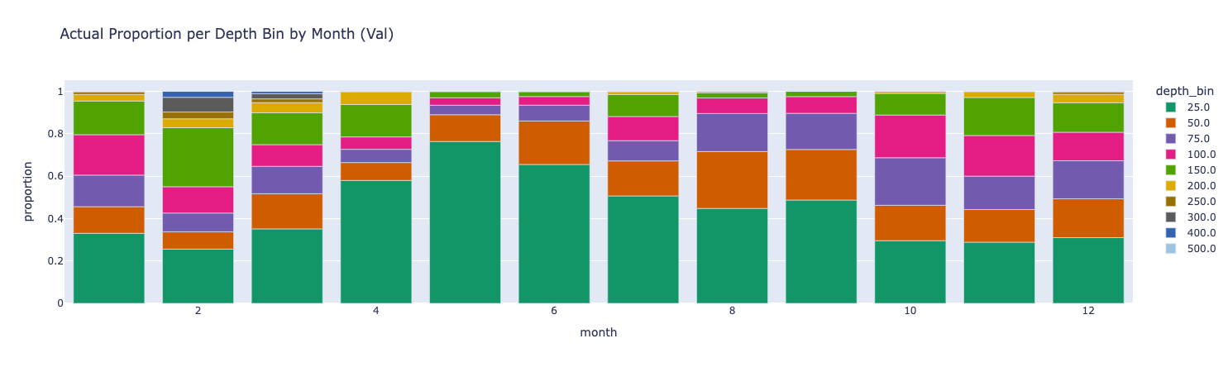
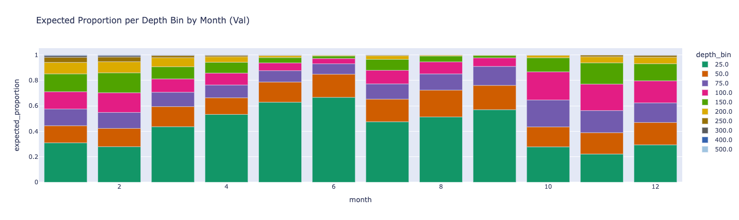
Figure 1: Seasonal Shifts in Depth Occupancy. (Top) Using observations of depth at 15-minute intervals from individual Chinook salmon (GOA and EBS), the proportions of samples in each depth bin across all months. (Bottom) For those same samples, mean predicted probability of the occupied depth from a deep learning model bin across all months.
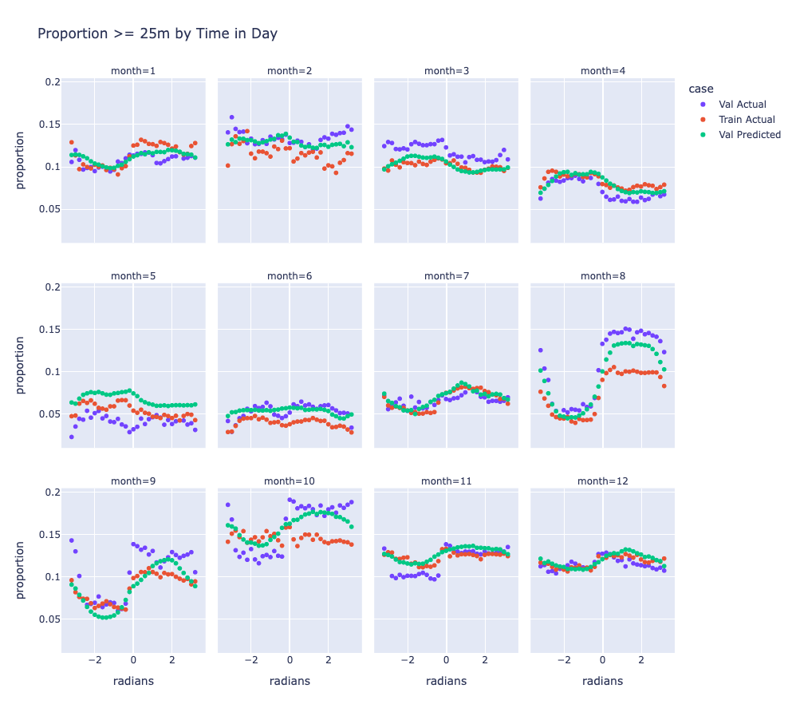
Figure 2: Diel Variation Using observations taken at 15-minute intervals from Chinook salmon in the GOA and EBS, the proportions of samples deeper than 25m as a function of time of day across all months. Validation Actual is the proportion over the validation data, Train Actual is the proportion over the training data, and Validation Predicted is the mean predicted probability of the occupied depth over the validation data.
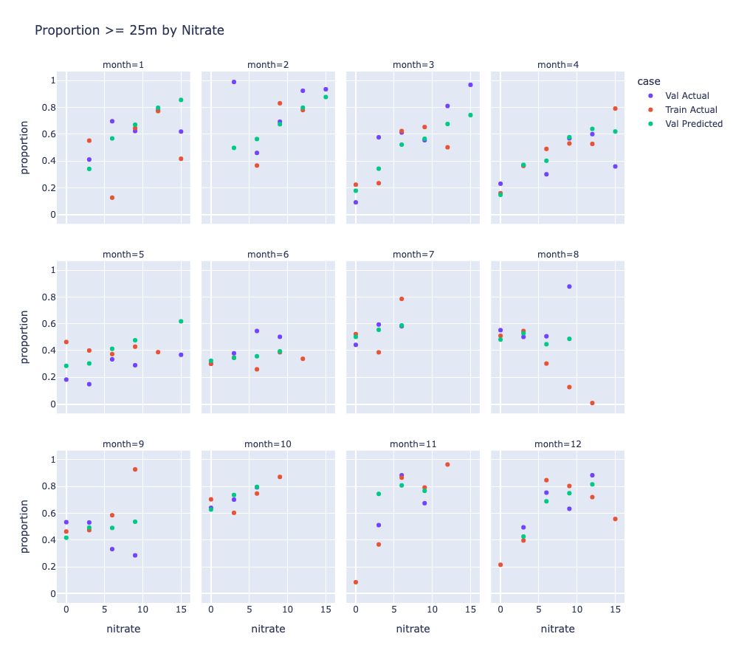
Figure 3: Proportions by Nitrate Bin Using observations taken at 15-minute intervals from Chinook salmon in the GOA and EBS, the proportions of samples deeper than 25m as a function of nitrate concentration. Validation Actual is the proportion over the validation data, Train Actual is the proportion over the training data, and Validation Predicted is the mean predicted probability of the occupied depth from a deep learning model over the validation data.
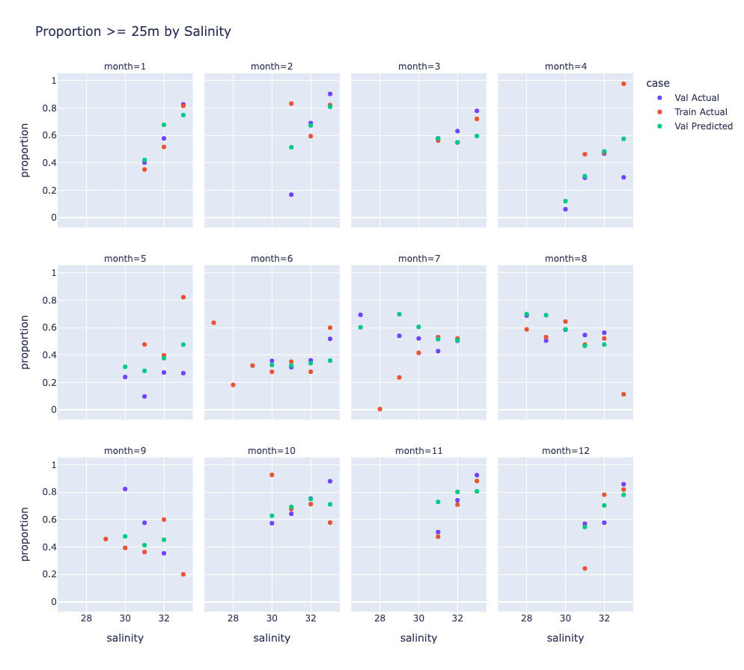
Figure 4: Proportions by Salinity Bin Using observations taken at 15-minute intervals from Chinook salmon in the GOA and EBS, the proportions of samples deeper than 25m as a function of salinity. Validation Actual is the proportion over the validation data, Train Actual is the proportion over the training data, and Validation Predicted is the mean predicted probability of the occupied depth from a deep learning model over the validation data.
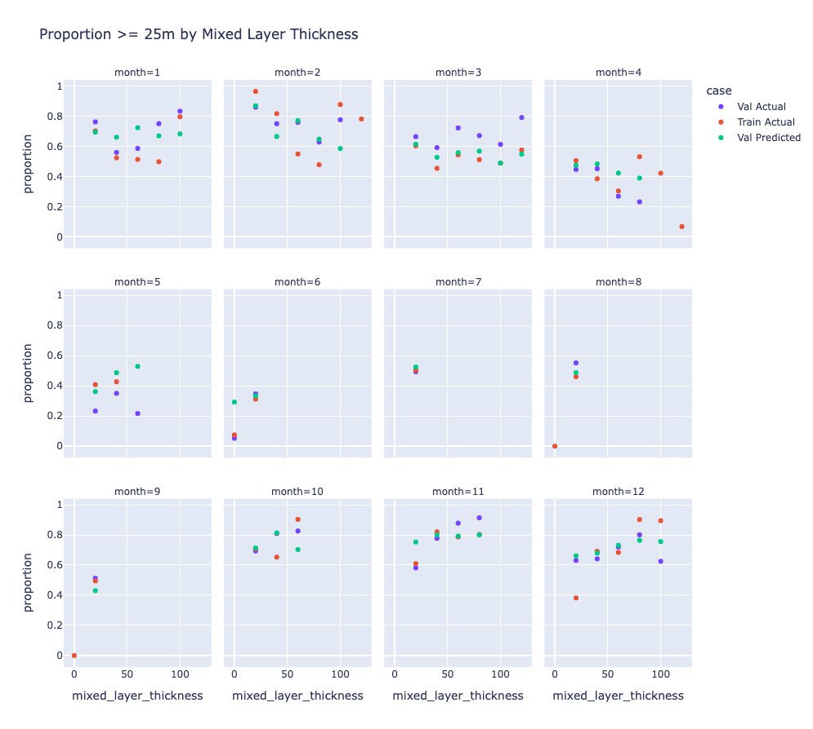
Figure 5: Proportions by Mixed Layer Thickness Bin Using observations taken at 15-minute intervals from Chinook salmon in the GOA and EBS, the proportions of samples deeper than 25m as a function of mixed layer thickness. Validation Actual is the proportion over the validation data, Train Actual is the proportion over the training data, and Validation Predicted is the mean predicted probability of the occupied depth from a deep learning model over the validation data.
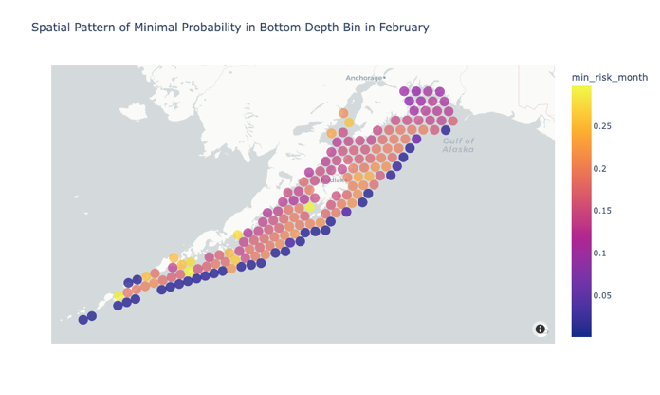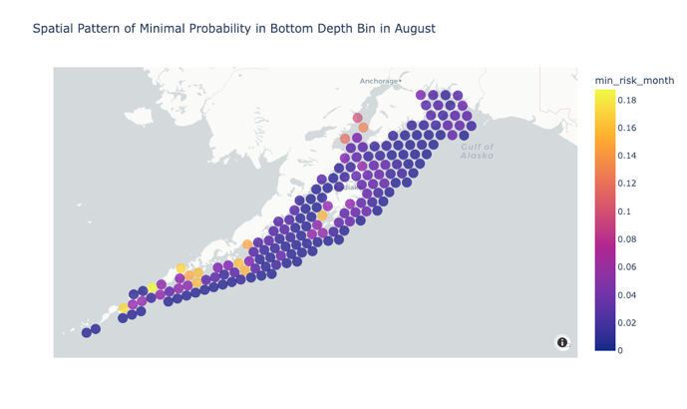
Figure 6: Spatial Distribution of Minimum Likelihood. Minimum likelihood of Chinook salmon occupancy in the deepest bin over each hour in the months of February (left) and August (right) as predicted by our deep learning model.
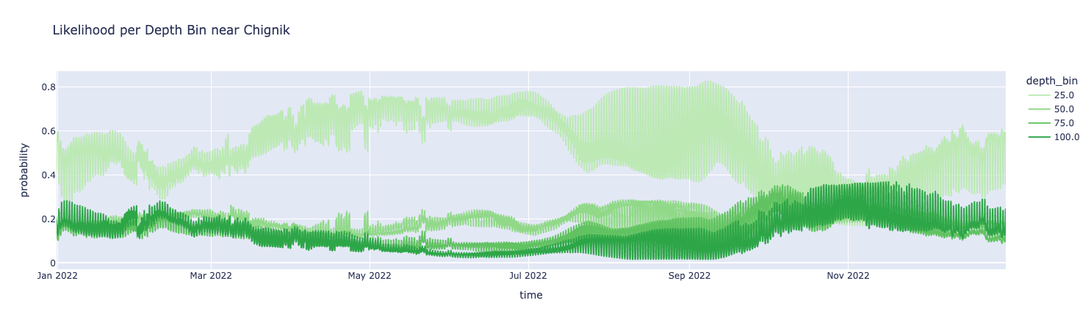
Figure 7: Full Year of Likelihoods Predicted likelihood, using our selected model, of occupancy per depth bin for Chinook salmon across all hours in 2022 for an H3 cell near Chignik, AK.
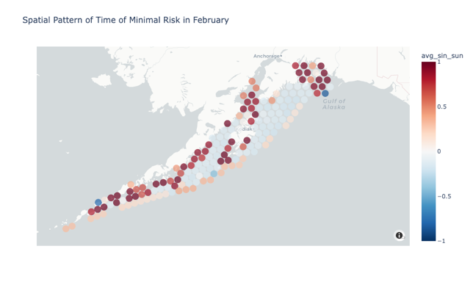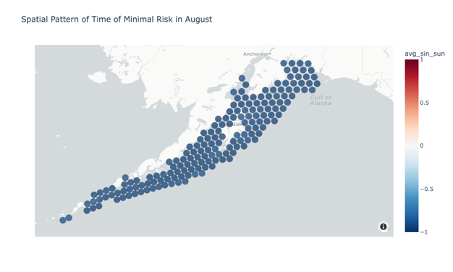
Figure 8: Time of Day Minimization. Time of day when the predicted likelihood, from our selected model, in the deepest bin for Chinook salmon is minimized on February (left) and August (right) 15. Negative values indicate nighttime whereas positive values indicate daytime.
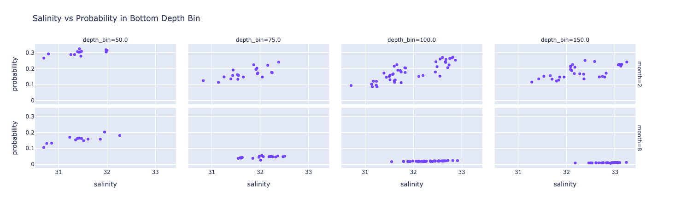
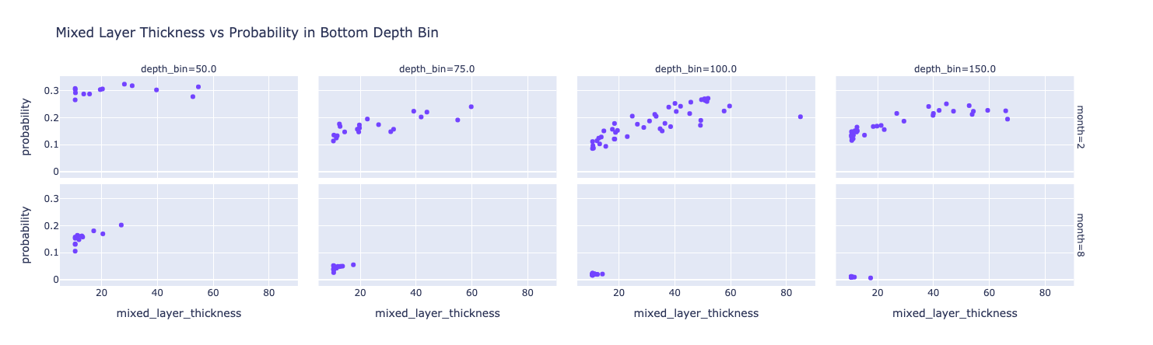
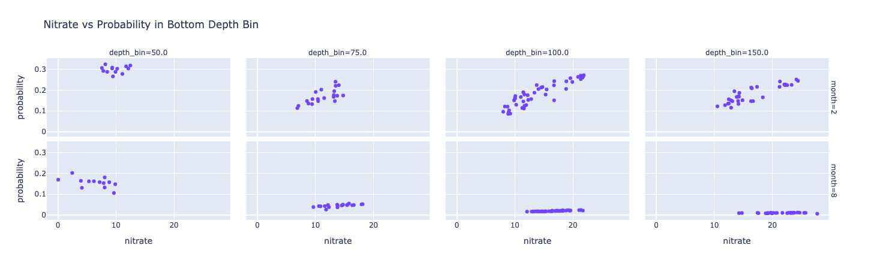
Figure 9: Likelihood of Bottom Occupancy vs Environmental Features The minimum likelihood, as predicted by our deep learning model, of Chinook salmon occupancy in the deepest bin vs the mean of the environmental features in that bin on February and August 15.

